MAJOR I PRACTICAL (Python)
PRACTICAL NO:-1
STUDY OF CRYPTOGRAPHY
Aim:-To study cryptography substitution technique
Program:-
import string

def ceaser_cipher(input_str):
ENCRYPT_SHIFT = 3
DECRYPT_SHIFT = -3
cipher_str = ""
plain_str = ""
for char in input_str:
if char in string.ascii_lowercase:
i = string.ascii_lowercase.index(char)
new_i = (i + ENCRYPT_SHIFT) % 26
cipher_str += string.ascii_lowercase[new_i]
elif char in string.ascii_uppercase:
i = string.ascii_uppercase.index(char)
new_i = (i + ENCRYPT_SHIFT) % 26
cipher_str += string.ascii_uppercase[new_i]
else:
cipher_str += char

print(f"Encrypted (Cipher Text) :\t{cipher_str}")
for char in cipher_str:
if char in string.ascii_lowercase:
i = string.ascii_lowercase.index(char)
new_i = (i + DECRYPT_SHIFT + 26) % 26
plain_str += string.ascii_lowercase[new_i]
elif char in string.ascii_uppercase:
i = string.ascii_uppercase.index(char)
new_i = (i + DECRYPT_SHIFT + 26) % 26
plain_str += string.ascii_uppercase[new_i]
else:
plain_str += char
print(f"Decrypted (Plain Text) :\t{plain_str}")

print("Enter a String :", end="\t")
user_input = input()
ceaser_cipher(user_input)

Output:-
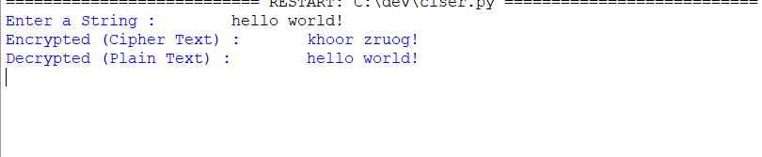

Conclusion :-The above program is successfully executed
PRACTICAL NO:-2
STUDY OF SYMMETRIC KEY - DES & AES
2)a)Aim:-To write python code for DES
Program:-
import pyDes
key = b"mysecret"
data_to_encrypt = b"Hello from DES!"
cipher = pyDes.des(key, padmode = pyDes.PAD_PKCS5)
encrypted_data = cipher.encrypt(data_to_encrypt)
print (f"Original Data: {data_to_encrypt.decode()}")
print (f"Encrypted Data Looks like this: {encrypted_data}")
decrypted_data = cipher.decrypt(encrypted_data)
print (f"Decrypted Data: {decrypted_data.decode()}")

Output:
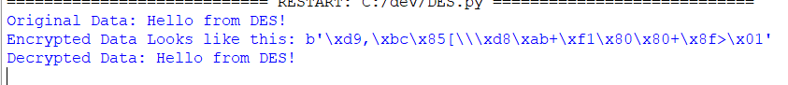
Conclusion :-The above program is successfully executed

2)b)Aim:-To write a code in python for AES
Program:-
from Crypto.Cipher import AES
from Crypto.Util.Padding import pad, unpad
key = b'my_secret_key_16' # exactly 16 bytes
data_to_encrypt = b'Hello from modern AES!'
cipher = AES.new(key, AES.MODE_CBC)
iv = cipher.iv

encrypted_data = cipher.encrypt(pad(data_to_encrypt, AES.block_size))

print (f"Original Data: {data_to_encrypt.decode()}")
print (f"Encrypted Data looks like this: {encrypted_data}")
decrypt_cipher = AES.new(key, AES.MODE_CBC, iv)
decrypted_data=unpad(decrypt_cipher.decrypt(encrypted_data), AES.block_size)
print (f"Decrypted Data: {decrypted_data.decode()}")

Output: 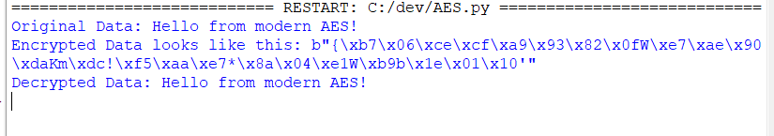

Conclusion :-The above program is successfully executed

PRACTICAL NO 3
STUDY OF ASYMETRIC KEY (DH & RSA)
3)a)Aim:-To write a python code for DH
Program:-
from cryptography.hazmat.primitives.asymmetric import dh
from cryptography.hazmat.primitives import serialization
from cryptography.hazmat.backends import default_backend
parameters = dh.generate_parameters(generator=2, key_size=512, backend=default_backend())
alice_private_key = parameters.generate_private_key()
alice_public_key = alice_private_key.public_key()
bob_private_key = parameters.generate_private_key()
bob_public_key = bob_private_key.public_key()
alice_shared_key = alice_private_key.exchange(bob_public_key)
bob_shared_key = bob_private_key.exchange(alice_public_key)
print(f"Alice's Shared Secret: {alice_shared_key}")
print(f"Bob's Shared Secret: {bob_shared_key}")
if alice_shared_key == bob_shared_key:
print("\nSuccess! Shared keys match.")
else:
print("\nError! Shared keys do not match.")
Output:
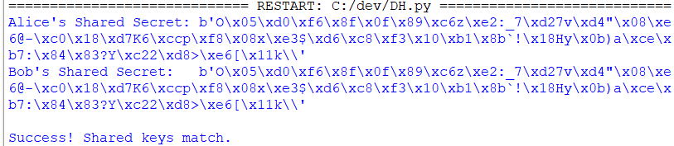

Conclusion :-The above program is successfully executed

3)b)Aim:-To write a code in python code for RSA
Program:-
from Crypto.PublicKey import RSA
from Crypto.Cipher import PKCS1_OAEP
key = RSA.generate(2048)
private_key = key
public_key = key.public_key()
data_to_encrypt = b'This is a top secret RSA message'
print (f"Original Data: {data_to_encrypt.decode()}")
cipher_rsa = PKCS1_OAEP.new(public_key)
encrypted_data = cipher_rsa.encrypt(data_to_encrypt)
print (f"Encrypted Data looks like this: {encrypted_data}")
decrypt_rsa = PKCS1_OAEP.new(private_key)
decrypted_data = decrypt_rsa.decrypt(encrypted_data)
print (f"Decrypted Data: {decrypted_data.decode()}")
assert data_to_encrypt == decrypted_data
print("Success! The message was encrypted and decrypted correctly.")

Output:
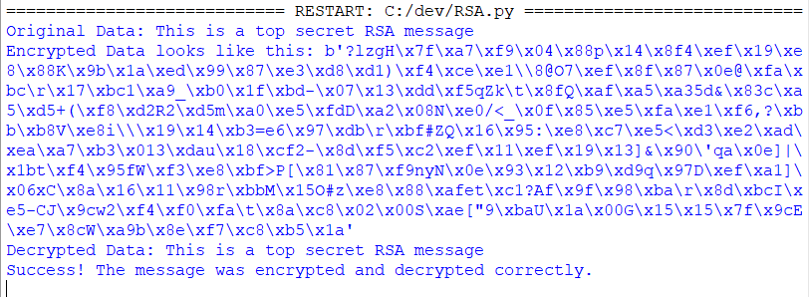
Conclusion :-The above program is successfully executed

PRACTICAL NO 4
STUDY OF MD5 ALGORITHM
Aim:- To write code in python in MD5
Program:-
import hashlib
data = "Hello, this is a test string"
md5_hash_object = hashlib.md5(data.encode())
hex_digest = md5_hash_object.hexdigest()
print (f"Original String : {data}")
print (f"MD5 Hash: {hex_digest}")

Output:-
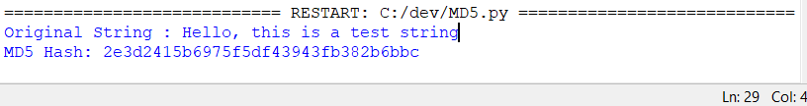
Conclusion :-The above program is successfully executed
PRACTICAL NO 5
STUDY OF HASH FUNCTION
Aim:-To write code in python for hash fuction
Program:-
def RSHash (data_string):
a = 378551
b = 63689
hash_value = 0
for char in data_string:
hash_value = hash_value * a + ord(char)
a = a * b
return hash_value
data = "hello world"
hash_result = RSHash(data)
print (f"Original String: {data}")
print (f"RS Hash Value: {hash_result}")
data2 = "world hello"
hash_result2 = RSHash(data2)
print (f"\nOriginal String: {data2}")
print (f"RS Hash Value: {hash_result2}")
Output:
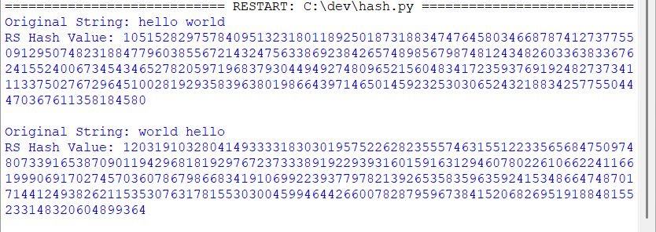
Conclusion :- The above program is successfully executed

